[붙임2-1 초록 예시]

**발표형식**

**한국 부식의 역사**

**Korean Corrosion History**

홍길동1,*, 이부식1, 김방식2, †

1한국부식대학교 신소재공학과, 2한국방식대학교 재료공학과

**1. 서론**

Hong *et al.* [1] 연구에 따르면 동관은 뛰어난 내식성을 보여준다 [2-7].

**2. 실험 방법**

구리 배관의 외면의 표면 사진(Fig. 1a)과 내면의 표면 사진(Fig. 1b)를 살펴보면~ .

**Table 1. Weight fraction variation as a function of time [4-6]**

|  |  |  |  |  |  |
| --- | --- | --- | --- | --- | --- |
| Year | 1970 | 1980 | 1990 | 2000 | 2010 |
| wt% | 30 | 60 | 90 | 150 | 250 |

(표 삽입시 그림 제목과 해당 내용 영문으로)

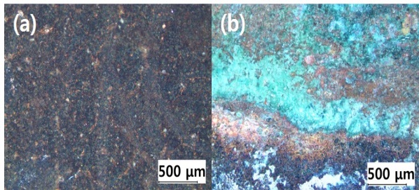

**Fig. 1. Oxide scale on the surface of copper pipe in (a) inner and (b) outer regions**

**(**그림 삽입시 그림 제목과 해당 내용 영문으로)

2H＋ + 2e－ → H2 (1)

(문장 중에 수식 언급시 equation (1), equation (2) 로 나타낸다)

**3. 결과 요약**

본 실험결과는 ~ .

**References**

1. K. T. Kim, Y. R. Yoo, and Y. S. Kim, Atmospheric Corrosion and Surface Appearance of Galvalume Steel following Outdoor Exposure for 36 Months: A Korean Study, *Corrosion Science and Technology*, **19**, 326 (2020).

2. G. D. Hong and Y. H. Kim, *Proc. 5thCorrosion History Conf.*, p. 32, Korean Corrosion History Institute, Seoul, Korea (2011).

*발표자

†Corresponding author: gdhong2000@hankook.ac.kr

[붙임2-2 영문 논문 예시]

**Korean Corrosion History**

Gil-Dong Hong1,† and Young-Hee Kim2

*1Department of Materials Science and Engineering, Hankook University, Sejong-si, 12345, Korea*

*2Department of Korean History, Hankook University, Sejong-si, 12345, Korea*

Abstract: Copper metal is widely used in~ (150-200 words)

***Keywords:*** *corrosion, erosion, oxidation, metal, electrochemical society* (Maximum 5 keywords)

†Corresponding author: gdhong2000@hankook.ac.kr

Gil-Dong Hong: Professor, Young-Hee Kim: Ph. D. Student

**1. Introduction**

According to Hong *et al.* [1], copper has superior corrosion resistance [2-7].

**2. Experimental Methods**

Inner surface (Fig. 1a) and outer surface (Fig. 1b) of copper pipe show~

**Table 1. Weight fraction variation as a function of time [4-6]**

|  |  |  |  |  |  |
| --- | --- | --- | --- | --- | --- |
| Year | 1970 | 1980 | 1990 | 2000 | 2010 |
| wt% | 30 | 60 | 90 | 150 | 250 |

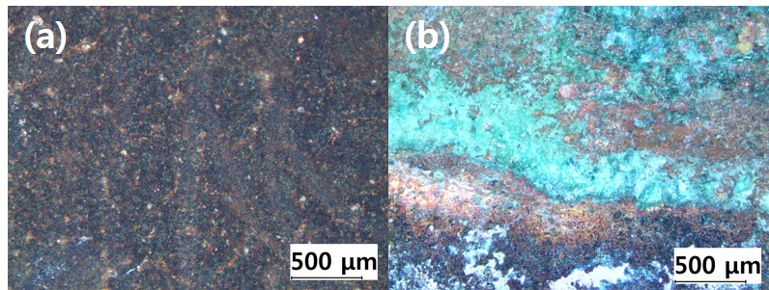

**Fig. 1. Oxide scale on the surface of copper pipe in (a) inner and (b) outer regions (example)**

2H＋ + 2e－ → H2 (1)

According to equation (1), ~

**3. Results**

(Times New Roman, 12 point, double spacing)

**3.1**

(Times New Roman, 12 point, double spacing)

**3.2**

(Times New Roman, 12 point, double spacing)

**4. Discussion**

(Times New Roman, 12 point, double spacing)

**4.1**

(Times New Roman, 12 point, double spacing)

**4.2**

(Times New Roman, 12 point, double spacing)

**5. Conclusions**

(Times New Roman, 12 point, double spacing)

**Acknowledgments**

(If needed, please use the followings: Times New Roman, 12 point, double spacing)

**References**

(Type all the references following the format given below; (1) journal, (2) conference proceeding, (3) books, (4) standard, (5) patent, (6) web page, (7) thesis)

1. K. T. Kim, Y. R. Yoo, and Y. S. Kim, Atmospheric Corrosion and Surface Appearance of Galvalume Steel following Outdoor Exposure for 36 Months: A Korean Study, *Corrosion Science and Technology*, **19**, 326 (2020). Doi: <https://doi.org/10.14773/CST.2020.19.6.326>

2. G. D. Hong and Y. H. Kim, *Proc. 5th Corrosion History Conf.*, p. 32, Korean Corrosion History Institute, Seoul, Korea (2011). Doi: https://doi.org/~

3. G. D. Hong and G. J. Lim, *Corrosion and History*, *3rd ed.*, p. 100, John Wiley & Sons, New York (1985). Doi: https://doi.org/~

4. KS B ISO52949, Evaluation of corrosion resistance of copper (2013).

5. K. Hong, The anticorrosion solution for the bottom of vehicle, 20-2013-0003597 (2014.03.29).

6. G. D. Hong, Korean Corrosion History, http://www.corrosionhistory.go.kr/kor (2009).

7. G. D. Hong, Ph.D. Thesis, pp. 85 - 105, Daehan University, Seoul (2015).

1. When you prepare the manuscript, please refer to “Instruction for Authors”, Use 12 font size in Times New Roman)
2. A small publication fee shall be charged for publication in the Journal and the new manuscript should be submitted after the receipt of payment of the yearly membership fee or the unpaid publication charge.
3. All papers should be written in English and SI units should be used throughout the manuscript. Always make a space between number and unit, e.g. 5 mm (exception: 5%, 5˚). Defined abbreviations must be used, e.g. 5 wt% (5 wt.%: incorrect), 5 vol% (5 vol.%: incorrect).

**※ 저널홈페이지 논문 투고 규정 등 안내 URL**

**:** [**https://www.j-cst.org/main/guidelines.htm**](https://www.j-cst.org/main/guidelines.htm)

[붙임2-3 국문 논문 예시]

**한국 부식의 역사**

홍길동1,†, 김영희2

1한국대학교 신소재공학과, 세종특별자치시 조치원읍 세종로 2000

2한국대학교 국사학과, 세종특별자치시 조치원읍 세종로 2000

**Korean Corrosion History**

Gil-Dong Hong1,† and Young-Hee Kim2

*1Department of Materials Science and Engineering, Hankook University, Sejong-si, 12345, Korea*

*2Department of Korean History, Hankook University, Sejong-si,12345, Korea*

Abstract: Copper metal is widely used in~ (영문, 150-200 단어)

***Keywords:*** *Corrosion, Erosion, Oxidation, Metal, Electrochemical society* (영문, 최대 5개)

†Corresponding author: gdhong2000@hankook.ac.kr

홍길동: 교수, 김영희: 박사과정

**1. 서론**

Hong *et al.* [1] 연구에 따르면 동관은 뛰어난 내식성을 보여준다 [2-7]. (내용, 바탕체, 글자크기 12 point, 줄간격 160%)

**2. 연구방법**

**2.1 연구방법 소제목**

구리 배관의 외면의 표면 사진(Fig. 1a)과 내면의 표면 사진(Fig. 1b)를 살펴보면~ (내용, 바탕체, 글자크기 12 point, 줄간격 160%)

**Table 1. Weight fraction variation as a function of time [4-6]**

|  |  |  |  |  |  |
| --- | --- | --- | --- | --- | --- |
| Year | 1970 | 1980 | 1990 | 2000 | 2010 |
| wt% | 30 | 60 | 90 | 150 | 250 |



**Fig. 1. Oxide scale on the surface of copper pipe in (a) inner and (b) outer regions (example)**

**(**그림 삽입시 그림 제목과 해당 내용 영문으로)

**2.2 연구방법 소제목**

내용 (바탕체, 글자크기 12 point, 줄간격 160%)

**3. 연구결과 및 고찰**

내용 (바탕체, 글자크기 12 point, 줄간격 160%)

**4. 결론**

내용 (바탕체, 글자크기 12 point, 줄간격 160%)

**감사의 글**

저자의 필요에 따라 기술함. (바탕체, 글자크기 12 point, 줄간격 160%)

**References**

**참고문헌이 (1)저널, (2)학회 프로시딩, (3)단행본, (4)표준규격, (5)특허, (6)웹페이지, (7)학위논문의 경우 아래와 같은 순서로 작성한다.**

1. K. T. Kim, Y. R. Yoo, and Y. S. Kim, Atmospheric Corrosion and Surface Appearance of Galvalume Steel following Outdoor Exposure for 36 Months: A Korean Study, *Corrosion Science and Technology*, **19**, 326 (2020). Doi: <https://doi.org/10.14773/CST.2020.19.6.326>

2. G. D. Hong and Y. H. Kim, *Proc. 5th Corrosion History Conf.*, p. 32, Korean Corrosion History Institute, Seoul, Korea (2011). Doi: https://doi.org/~

3. G. D. Hong and G. J. Lim, *Corrosion and History*, *3rd ed.*, p. 100, John Wiley & Sons, New York (1985). Doi: https://doi.org/~

4. KS B ISO52949, Evaluation of corrosion resistance of copper (2013).

5. K. Hong, The anticorrosion solution for the bottom of vehicle, 20-2013-0003597 (2014.03.29).

6. G. D. Hong, Korean Corrosion History, http://www.corrosionhistory.go.kr/kor (2009).

7. G. D. Hong, Ph.D. Thesis, pp. 85 - 105, Daehan University, Seoul (2015).

1. 투고 규정에 맞게 기술함. (Instruction for Authors 참고, Times New Roman 12)
2. 학회지에 게재된 논문은 소정의 게재료를 납부하여야 하며, 회원으로서 당해연도 회비 미납자 또는 게재료 미납자는 이를 납부한 후에 논문을 접수하도록 한다.

③ 원칙적으로 숫자와 단위는 띄어쓰기를 한다(예외: 5%, 5˚). 단위의 약자를 사용 시 5 wt% (5 wt.%: 옳지 않음), 5 vol%와 같이 사용되어야 한다.